AWARD ENTRY FORM
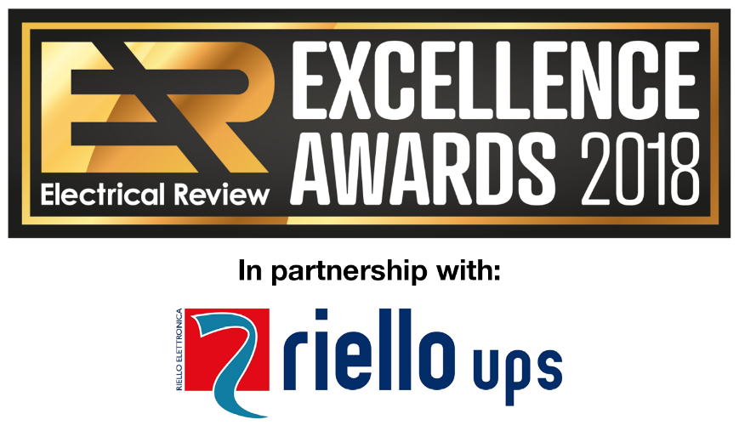
www.electricalreview.co.uk/awards
The Electrical Review Excellence Awards celebrate outstanding achievements within electrical projects over the past year. We are excited to learn about the project you are about to enter!
To enter a project, you can be the project owner, a contractor, sub-contractor or vendor directly involved in the project.
- Shortlist will be announced in April
- Winners will be announced at the Awards evening on 24 May 2018 at The Dorchester, London
Please complete this form and email to marcinp@sjpbusinessmedia.com
You can also submit your entry online – CLICK HERE
*indicates mandatory information

- * Please provide your details. We may contact you for additional information
Title
First Name
Surname
Job Title
Organisation
Email
Telephone
Full Postal Address

- * Please highlight the Award you are entering.
2018 Electrical Review Award for Excellence in...
- POWER
- DATA CENTRE DESIGN & BUILD – Panel building & Enclosures
- DATA CENTRE DESIGN & BUILD – Climate Control
- DATA CENTRE DESIGN & BUILD – UPS / Standby Power
- LIGHTING – Emergency Lighting
- LIGHTING – Smart
- CABLE MANAGEMENT
- FIRE SAFETY & SECURITY
- ENERGY EFFICIENCY
- INNOVATION
Please note that all winning entries will also be considered for our 2018 Project of the Year Award presented by Riello UPS, to be announced during the Awards evening.
- * What is the name of the main / host project?
E.g. Hospital Building A, Manufacturing Plant B, Power Station C etc.

- * What is the element of the project you are submitting for the Award?
E.g. Cabling Installation, UPS etc.

- * I am:
Please highlight as appropriate
- The main project owner
- A vendor providing products / services / technical solutions used in the project
- A contractor / sub-contractor / site manager / consultant
- Other (please specify):

- * Where is the project located?
Please enter the full postal address.

- * Start and completion date. E.g. 1 April 2017 - 1 Dec 2017.
Please note: Project must be completed by end of 2017
Started on:
Completed on:

ENTRY DETAILS
Here we ask you to describe the project details specifically relevant to the Award.
E.g. if you are submitting a Cabling Installation at a Manufacturing Plant for the Cable Management Award, focus only on the details relevant to Cabling.
You can expand the text boxes for more space.
There is no word count limit, so you are free to include any relevant information. However, please keep the information clear and concise. The Judges may not like entries with just a few bullet points, nor are they likely to be impressed with long, unfocused copy!
- * Please outline your brief and key objectives.

- * Please outline the process you followed to deliver these objectives.
Tell us about your plan to ensure the objectives were met and/or exceeded, and how you worked through the key steps to completion.

- * Please highlight specific examples of excellence you would like the Judges to pay attention to, in context of this Award.

This is your chance to describe your successes, achievements and any challenges you overcame in the process of delivering the project, or other reasons why you believe this project should be rewarded by the Judges.

- * Please describe any specific technical solutions you have implemented that made a positive difference to the project.

This can include hardware or software, off-the-shelf or custom made for the project.

- If you worked with other organisations, suppliers or 3rd parties who were instrumental in the success of this project, please name them below and describe your collaboration, highlighting any examples of excellence.

- If you have any testimonials or further additional information to support your case to win this Award, please add it below.

- Additional materials supporting your Award entry, such as images and documents.

Pease email these to marcinp@sjpbusinessmedia.com together with the completed Entry Form.

Please make sure you clearly name / label the files. We recommend converting text documents (Word, Pages etc.) to PDF first to avoid formatting issues.

