AWARD ENTRY FORM
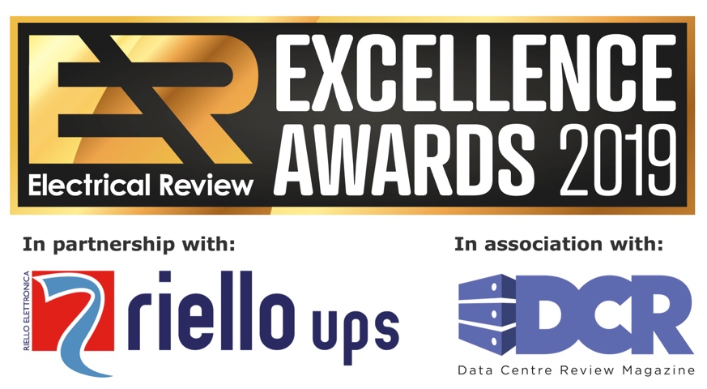
www.electricalreview.co.uk/awards
The Electrical Review Excellence Awards celebrate outstanding achievements within the electrical industry over the past year. We are excited to learn about the projects and/or products you are about to enter!
To enter a project, you can be the project owner, a contractor, sub-contractor or vendor directly involved in the project. To enter a product, you can be the manufacturer, distributor or user.
- Entries close on 18 April 2019. Shortlist will be announced by end of April 2019
- Winners will be announced at the Awards evening on 30 May 2019 at The Four Seasons Hotel, Park Lane, London
Please complete this form and email to marcinp@sjpbusinessmedia.com

*indicates mandatory information

- * Please provide your details. We may contact you for additional information
Title
First Name
Surname
Job Title
Organisation
Email
Telephone
Full Postal Address

- * Please highlight the Award/s you are entering
You may highlight more than one Award where relevant. However, be sure to provide sufficient information for the Judges to consider your entry for each of the Awards you highlight. We recommend submitting separate entries (see Notes below).
2019 Electrical Review Award for Excellence in...
- POWER - Product of the Year
- POWER - Project of the Year
- LIGHTING - Product of the Year
- LIGHTING - Project of the Year
- FIRE SAFETY & SECURITY - Product of the Year
- FIRE SAFETY & SECURITY - Project of the Year
- TEST & MEASUREMENT Product of the Year
- ENERGY EFFICIENCY PROJECT OF THE YEAR
- INNOVATIVE PROJECT OF THE YEAR
- SUSTAINABLE PROJECT OF THE YEAR
- DATA CENTRE DESIGN & BUILD - Product of the Year
- DATA CENTRE DESIGN & BUILD - Project of the Year
- DATA CENTRE CLOUD - Product of the Year
- DATA CENTRE CLOUD - Project of the Year
- DATA CENTRE Colocation Supplier of the Year
Please note that all winning entries will also be considered for our Project of the Year and Product of the Year Awards, to be announced during the Awards evening.
- * What is the name of the Project or Product you are submitting?
- if entering a Project, specify which element: e.g. UPS in Hospital Building A, Cabling in Manufacturing Plant B etc.
- if entering a Product, specify the model / version if appropriate: e.g. Data Centre Rack A 2018, Luminaire B v2 etc.

- FOR PROJECTS ONLY | Project location and start / completion date:
Location:
Started on:
Completed on:

- FOR PRODUCTS ONLY | Product release date:

ENTRY DETAILS
NOTES:
Here we ask you to describe the details specifically relevant to the Award you are entering.
Consider submitting multiple entries. For example, a lighting manufacturer may enter their new luminaire for the LIGHTING - Product of the Year Award, focusing on the specific features and benefits of this model of luminaire. However, if this product was also used as part of a lighting upgrade project at a school, then the manufacturer may also submit a separate entry for LIGHTING - Project of the Year Award, focusing on the benefits of the lighting installation as a whole for this specific school.
You can expand the text boxes for more space.
There is no word count limit, so you are free to include any relevant information. However, please keep the information clear and concise. The Judges may not like entries with just a few bullet points, nor are they likely to be impressed with long, unfocused copy!
- * Please outline your brief and key objectives for the Project or Product you are entering, and the process you followed to deliver these objectives.

- * Please highlight the key features and benefits to the users / project owners.

- * Please highlight specific examples of excellence you would like the Judges to pay attention to, in context of this Award.

This is your chance to describe your successes, innovations, achievements and any challenges you overcame in the process, technical solutions or other reasons why you believe this project / product should be rewarded by the Judges.

- If you worked with other organisations, suppliers or 3rd parties who were instrumental in the process, please name them below and describe your collaboration, highlighting any examples of excellence.

- If you have any testimonials or further additional information to support your case to win this Award, please add it below.

- Additional materials supporting your Award entry, such as images and documents.

Please email these to marcinp@sjpbusinessmedia.com together with the completed Entry Form.

Please make sure you clearly name / label the files. We recommend converting this form and other text documents (Word, Pages etc.) to PDF first to avoid formatting issues.

