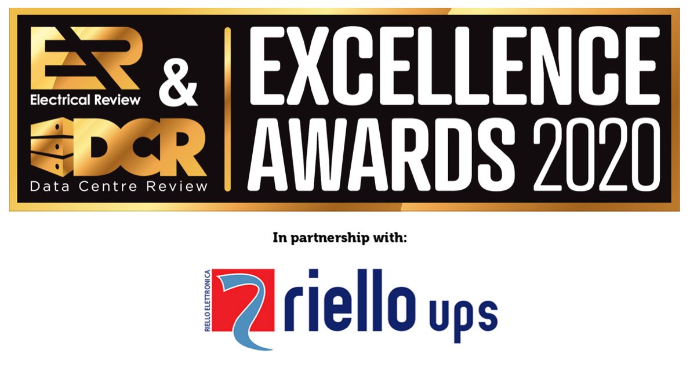
AWARD ENTRY FORM
www.electricalreview.co.uk/awards
The Electrical Review & Data Centre Review Excellence Awards celebrate outstanding achievements within the electrical and data centre industries over the past year. We are excited to read your submission!
- Entries close on 6 March 2020. Shortlist will be announced by 20 March 2020
- Winners will be announced at the Awards evening on 21 May 2020 in Central London
Please complete this form and email to marcinp@sjpbusinessmedia.com

*indicates mandatory information
- * Please provide your details. We may contact you for additional information
Title
First Name
Surname
Job Title
Organisation
Email
Telephone
Full Postal Address

* Please highlight the Award/s you are entering
You may highlight more than one Award where relevant. However, be sure to provide sufficient information for the Judges to consider your entry for each of the Awards you highlight. We highly recommend submitting separate entries.
2019 Award for Excellence in...
- POWER - Product of the Year
- POWER - Project of the Year
- LIGHTING - Product of the Year
- LIGHTING - Project of the Year
- FIRE SAFETY & SECURITY - Product of the Year
- FIRE SAFETY & SECURITY - Project of the Year
- ENERGY EFFICIENCY - Project of the Year
- ENERGY EFFICIENCY - Product of the Year
- INNOVATIVE PROJECT OF THE YEAR
- SUSTAINABLE PROJECT OF THE YEAR
- DATA CENTRE DESIGN & BUILD - Product of the Year
- DATA CENTRE DESIGN & BUILD - Project of the Year
- DATA CENTRE COOLING - Product of the Year
- DATA CENTRE COOLING - Project of the Year
- DATA CENTRE COLOCATION - Supplier of the Year
- CTO Of the Year
- Consultancy / Contractor of the Year
Please note that all winning entries will also be considered for our Project of the Year and Product of the Year Awards, to be announced during the Awards evening.
* What is the subject of your entry?
- If entering a Project, specify which element: e.g. UPS in Hospital Building A etc.
- If entering a Product, specify the model / version if appropriate: e.g. Luminaire B v2 etc.
- If entering a Consultancy/Contractor or Supplier, enter the name of the business
- If entering CTO of the Year, please enter their name and full job title

ENTRY DETAILS
NOTES:
Here we ask you to describe the details specifically relevant to the Award you are entering.
Consider submitting multiple (but separate) entries. For example, a lighting manufacturer may enter their new luminaire for the LIGHTING - Product of the Year Award, focusing on the specific features and benefits of this model of luminaire. However, if this product was also used as part of a lighting upgrade project at a school, then the manufacturer may also submit a separate entry for LIGHTING - Project of the Year Award, focusing on the benefits of the lighting installation as a whole for this specific school.
You can expand the text boxes for more space.
There is no word count limit, so you are free to include any relevant information. However, please keep the information clear and concise. The Judges may not like entries with just a few bullet points, nor are they likely to be impressed with long, unfocused copy!

- FOR PROJECTS ONLY | Project location and start / completion date:
Location:
Started on:
Completed on:

- FOR PRODUCTS ONLY | Product release date:

- * Please highlight the key features, benefits or achievements the Judges should take into consideration, in context of the Award you are entering
e.g.
- Brief objectives and how these were delivered, for Project or Product focused award
- Specific technical solutions and supporting metrics, for Power or Energy Efficiency award
- Particular personal initiatives, for CTO of the Year

- * Please highlight specific examples of excellence you would like the Judges to pay attention to, in context of the Award you are entering:
e.g.
- Ways your company went the extra mile/above and beyond
- Unique ways your product/project has benefitted the client

- Any other information to explain why you believe your entry should be rewarded by the Judges:

- If you have any testimonials or further additional information to support your case to win this Award, please add it below:

- Other materials / documents / media to support your Award entry

Please email these to marcinp@sjpbusinessmedia.com together with the completed Entry Form.

Please make sure you clearly name / label the files. We recommend converting this form and other text documents (Word, Pages etc.) to PDF first to avoid formatting issues.

