How do I register for an auction?
It's quick and easy. Just follow the steps below:
1. Log in to your account
2. Select the auction you wish to bid on under "auctions" then "current auctions"
3. Click "connect to auction"/ "register to bid"
4. Follow the steps to complete your sign up - you may be asked for card details at this stage.

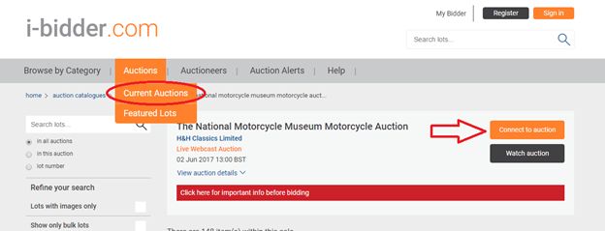

If you're already on the lot page, please click the small hammer icon next to the wording 'Register to Bid Online' in the tab to the right of the lot image.

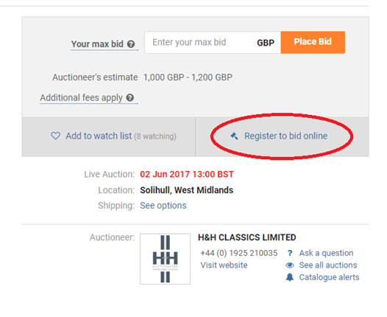

Once completed and approved by the auction house you will be able to bid by clicking "bid live now".

How do I know if I’m approved to bid?

Your auctioneer needs to approve your registration before you can bid – they’re the only ones who can let you participate in their auction.
We'll send you an email once the auctioneer has approved your registration, and on the day of the auction you’ll see the ‘bid’ button change from grey to blue – and then you’re good to go!
The time it takes to be approved can vary depending on the auctioneer - if you wish to speed this process up you might want to contact the auctioneer and make sure you've met their criteria to approve you. You can find their contact details on the 'Auctioneer' page.

