How to buy?

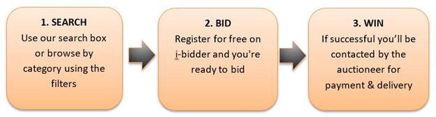

STEP 1 – SEARCH
If you know what you’re looking for, type it into the big search box on the homepage or at the top of any page on the site.
You can also browse through our categories using “Browse By Category” at the top of any page. Use the filters on the left of the screen to narrow down your search.
You can add items you’re interested in to your Watch List so you can view them all together in your My Bidder account.
You can set up an Auction Alert using the button at the top of the page. We’ll email you when new items that match your search are added to the site, so you’re always in the know.

STEP 2 – BID
Once you’ve found what you’re looking for, it’s time to get bidding. ‘If you haven’t already, create an account on i-bidder and register for the auction.
Before you bid, it’s best to check out the features and conditions of your item – and we’ve made it really easy with our ‘Ask a question’ tool lets you talk directly to the auctioneer about anything related to the auction.
Once you’re happy, there are a couple of ways to place your bid (depending on the type of auction):
Place a max bid – let us know the highest amount you're willing to pay and we'll bid for you, just enough to keep you in the lead up to your max bid. It’s the most convenient way to bid at auction.
Bid live – connect to a live auction in real-time and experience the atmosphere of the auction environment with live audio and video feeds. Engage with and bid at the auction directly via our live bidding panel.

STEP 3 – WIN
In timed auctions and some live auctions, we'll email you if someone bids more than you, so you have the chance to increase your max bid. Keep an eye on your Notifications so you have a chance to get your hands on the item you want.
For the best chance to win in a live auction, we recommend logging on when the auction is taking place and bidding live.
You can keep track of all your wins by logging in to My Bidder. Once the win is verified, the auctioneer will send you an invoice with details of your items and any further information about collection or delivery.

WE’RE HERE TO HELP
Visit our Help Centre where we’ve collated lots of information about using our site and the process of buying at auction - you'll find articles on everything from bidding to arranging delivery.
https://support.i-bidder.com/hc/en-gb

